Development Of A Portable Incubator For The Detection Of Coliform In Water Using Iot

Olonisakin David Akolade, Oguibe Favour Oziomachuwku, Omoruyi Osemwegie

Department of Electrical and Information Engineering

Covenant University,

Ota, Ogun State, Nigeria.

olonisakin.david@stu.cu.edu.ng

oguibe.favour@stu.cu.edu.ng

osemwegie.omoruyi@covenantuniversity.edu.ng

*Abstract*— Having access to clean and safe drinking water is considered a crucial human right, yet millions of individuals continue to live without it. The consumption of water that has been contaminated can increase the risk of experiencing outbreaks of different diseases that are transmitted through water, which are a leading cause of death worldwide. This project aims to develop a portable and low-cost incubator for detecting coliform bacteria in water, which is achieved by using a light-dependent resistor (LDR) and a heating element controlled by an IOT equipped microcontroller (ESP32). The incubator creates a controlled environment for water samples to incubate and for the LDR sensor to detect changes in turbidity, indicating the presence of coliform bacteria. Additionally, a Digital Humidity and Temperature (DHT11) sensor and a heating element helps maintain a temperature range of 35-37°C, the ideal temperature for optimal coliform bacteria growth. The incubator also features a Liquid Crystal Display (LCD) displaying resistance and temperature readings. After the data is collected, it is transferred to the microcontroller and subsequently transmitted to the Blynk application for continuous monitoring and analysis in real-time. The portability and affordability of this incubator makes it appropriate for use in remote areas where access to laboratory equipment is limited. This study carries significant implications for the advancement of low-cost and portable water quality monitoring systems, potentially leading to improvements in public health.

Keywords— portable incubator, coliform bacteria , water monitoring, light-dependent resistor (key words)

# Introduction

The research was inspired by the need for precise and trustworthy techniques for identifying waterborne infections, especially coliform bacteria, in places with few laboratory facilities. Coliform bacteria are used as a quality gauge for water and are a sign that potentially dangerous diseases may be present. Ensuring the availability of safe drinking water stands as a key priority in public health efforts because it is intimately related to human health. Consuming water that contains hazardous chemicals or pathogenic organisms has a major influence on one's health[1].

The lack of low-cost, simple-to-use, and accurate techniques for remote water monitoring and coliform detection is the key issue driving this research. Due to difficulties with transportation, sample storage, and inadequate laboratory facilities, traditional laboratory-based approaches are frequently not practical in remote places. Thus, the creation of a mobile incubator for coliform detection could be the answer to this issue.

The project is aimed towards developing a portable incubator that can quickly and accurately detect coliform bacteria in water using an approach that is both affordable and simple to use. One approach to detect these organisms involves filtering a 100 mL water sample through a membrane. Subsequently, the filtered membrane is incubated on specialized media at temperatures ranging from 35 to 37 °C for E. coli or 44 to 45 °C for TTC[2]. The issue of restricted access to laboratory facilities for water monitoring and coliform detection can be resolved by the portable incubator, especially in distant locations. The study is important because it may increase access to clean water, especially in locations where waterborne diseases are common. The mobile incubator might also be used for environmental research and monitoring, which would improve water management and public health.

# OVERVIEW OF EXISTING WATER QUALITY DETECTION METHODS

Diverse techniques for identifying waterborne contaminants have been developed and put to use in the effort to guarantee safe and clean drinking water. The merits and demerits of water quality detection technologies are highlighted in this chapter. This chapter lays the stage for the proposed construction of a portable incubator for the detection of coliform bacteria in water using IoT technology by addressing the drawbacks of present methods. The following are the existing water quality detection approaches:

1. **Culture-Based Methods**: To detect coliform bacteria and other microbes using traditional methods, water samples are cultured on specific media. These procedures deliver precise findings, but they frequently call for specialized facilities, knowledgeable staff, and protracted incubation times. Additionally, the requirement for sterile conditions may restrict their applicability in places with limited resources.
2. **Membrane Filter Method**: This technique entails passing a water specimen through a sterilized, bacteria-retaining 0.45-millimeter pore filter. Typical colonies on the filter are then counted after the filter has been cultured on a selective medium. Although this approach is more sensitive than direct culture, it still requires lengthy incubation times and poses a danger of cross-contamination.
3. **Enzymatic Method:** Coliforms possess the enzyme -galactosidase, which produces acids and gases at their optimum growth temperatures of 35 to 37 degrees Celsius (°C). Color or fluorescence is produced when a certain enzyme breaks down a chromogenic or fluorogenic substrate. These chemicals have been utilized to identify the presence or activity of specific enzymes in water. While it offers quicker results, it may lack specificity and sensitivity for certain strains[3].
4. **Polymerase Chain Reaction Method (PCR):** PCR-based techniques are used to rapidly detect DNA sequences specific to coliform bacteria. However, they require sophisticated equipment, skilled operators, and are generally better suited for centralized laboratories[4].

The prevalent traditional methods now in use have a significant flaw in terms of their time-intensive nature. This inherent trait frequently causes extended incubation periods, which slows the prompt dissemination of results. A further obstacle to conducting and gaining access to water quality evaluations is the urgent need for individuals with specialized training and well-equipped specialist laboratories. This situation is made worse in rural or underdeveloped areas where the lack of such resources presents a serious obstacle. Equally important is the significant obstacle created by the construction and maintenance of centralized laboratories. Particularly for towns endowed with little economic resources, the cost burden associated with acquiring the necessary equipment and maintaining the infrastructure required for thorough water quality investigation can be extremely onerous. The implementation of a thorough water quality examination consequently becomes a challenging task.

It becomes clear that a paradigm shift towards more effective, accessible, and affordable approaches for monitoring water quality is essential in light of these numerous limitations. Such a change will not only hasten the release of important findings but also democratize access to precise water quality evaluation across various geographic and economic contexts.

**Proposed Solution: Portable Incubator for Coliform Detection**

This project seeks to create a portable incubator outfitted with IoT technology for the quick and accurate identification ofcoliform bacteria in water, drawing inspiration from the difficulties seen in current methods for determining the quality of the water. The proposed incubator aims to overcome the limitations of conventional methods by utilizing IoT's capabilities

1. **Real-time monitoring:** The use of IoT allows for remote data transfer and continuous monitoring, which minimizes response times and the requirement for physical presence.
2. **Field Applicability:** The incubator's portability makes it possible to conduct testing locally rather than having to send samples to other cities or countries for analysis.
3. **User-Friendly:** The design intends to streamline usage, enabling testing at the community level and accessibility to non-specialist users.
4. **Cost-Effective:** The suggested incubator aims to provide a more affordable option for monitoring water quality by avoiding the need for costly laboratory facilities.

# System Design and Methodology

The design was done with an ESP 32 microcontroller for data transmission of the sensor reading: LDR, DHT11, PTC heater controlled by a relay to BLYNK for visualization and a 12v Dc Power supply unit to power the incubator. The system is fully covered as:

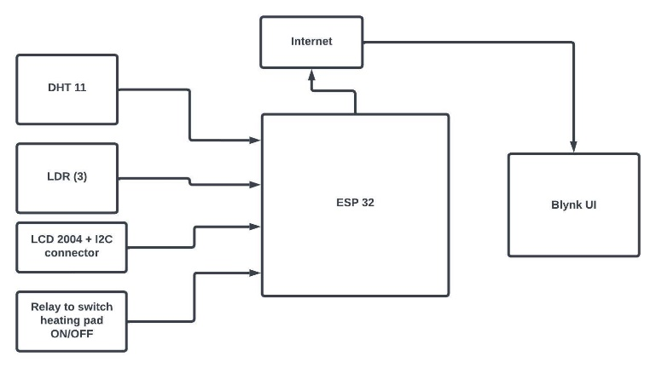

Figure 1: *Overview of Interaction of Component parts of the Portable Incubator*

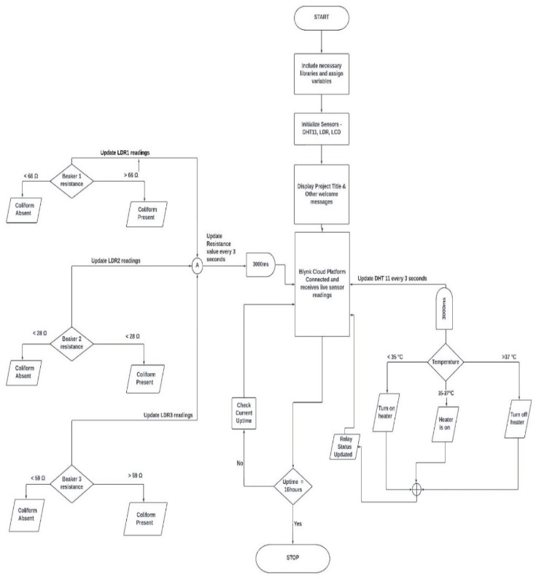

Figure 2: *Flowchart for the Portable Incubator*

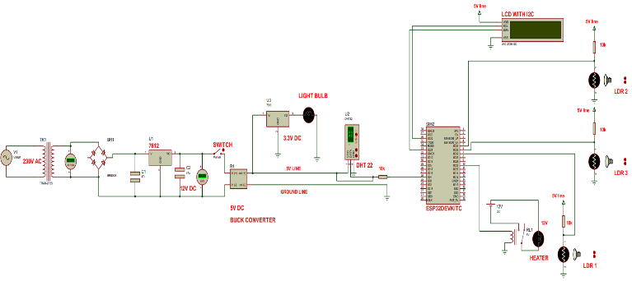

Figure 3: *Circuit Diagram for the Portable Incubator*

# Implementation and Testing

For system implementation the ESP32 is selected as the controller of choice. The testing phase comes after the actual system has been implemented based on the design specifications.

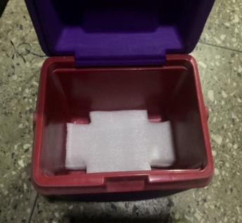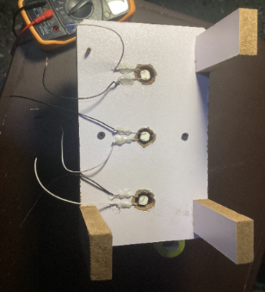

Figure 4: *Building the Portable Incubator*

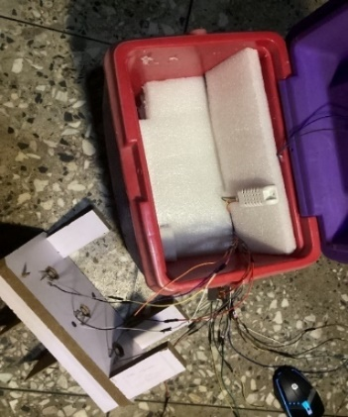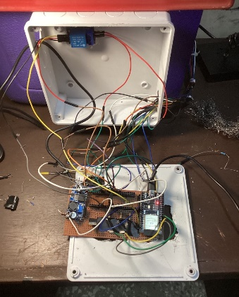

Figure 5: *Electrical Connections*

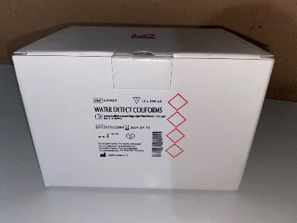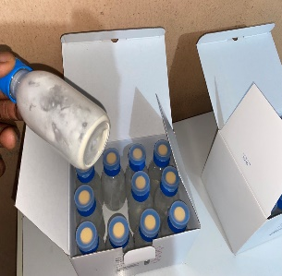

Figure 6: *Coliform Detect Powder*

**Mixture of the coliform detect powder with our water sample**

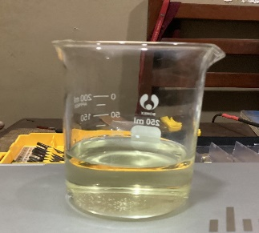

Golden hue Darkish green(after 16hours of incubation)

Figure 7: *Test Results*

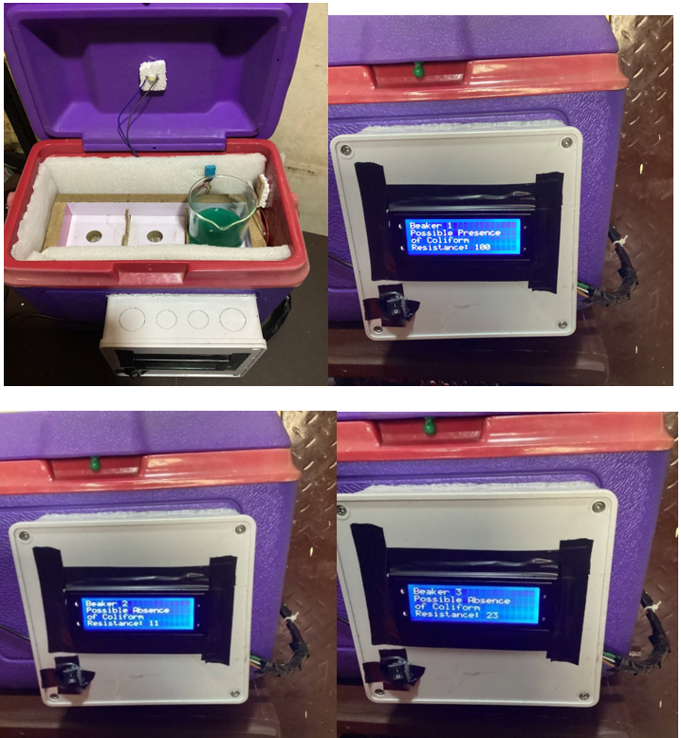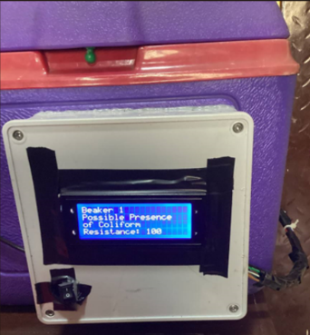

Figure 8: *Test 1- Beaker Placement on LDR1*

In this test, the beaker containing the contaminated water sample was placed directly on top of LDR 1. The LDR's response to the presence of coliform-contaminated water was recorded, and the resulting resistance readings were observed. The experiment provided insights into how LDR 1 detected the contamination based on the proximity of the sample.

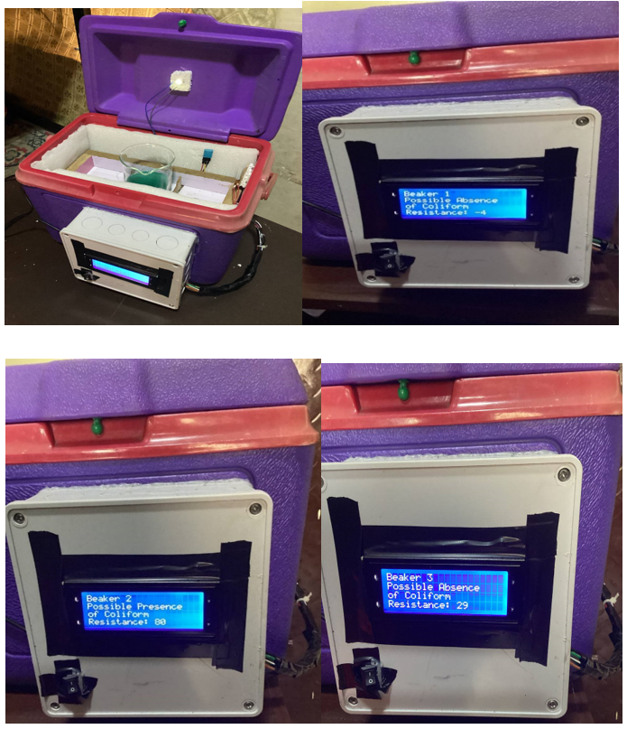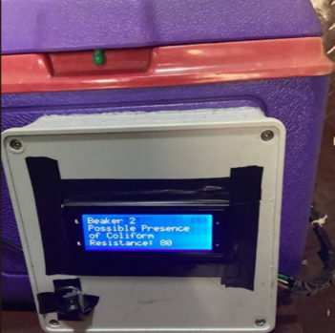

Figure 9: *Test 2 - Beaker Placement on LDR2*

For the second test, the same contaminated water sample beaker was placed on top of LDR 2. The LDR's response was again recorded, and the resistance readings were compared to the readings obtained in Test 1. This comparison helped assess whether different LDR locations within the incubator affected the detection process.

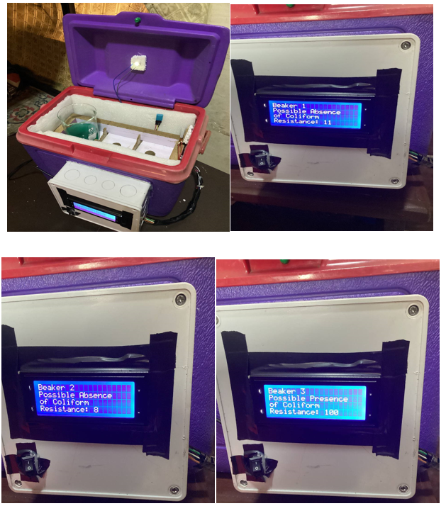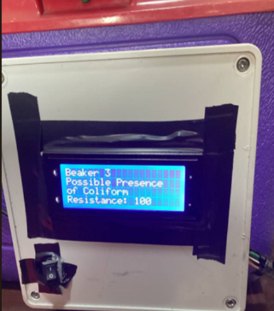

Figure 10: *Test 3 - Beaker Placement on LDR3*

In the third test, the contaminated water sample beaker was positioned on LDR 3. Just like in the previous tests, the LDR readings were captured, and the variations were analyzed. This test provided further data on the relationship between LDR location and the accuracy of coliform detection.

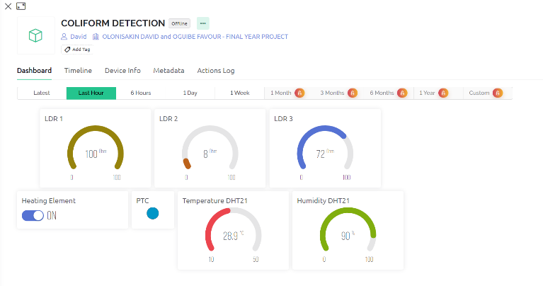

Figure 11: *Blynk GUI used for real-time monitoring*

# Conclusion

This paper presents an effective mode of detecting coliform in water using Iot. This provides a quick and cheaper alternative to traditional lab examination. We achieved the following:

a. Successful design and construction of the portable incubator establishing a controlled environment, ensuring precise temperature control within the necessary range for coliform growth and detection.

b. The integrated LDR sensor demonstrated its capability to monitor coliform presence and growth through changes in resistance. Calibrated LDR readings, correlated with coliform levels, enabled real-time monitoring via the user-friendly Blynk app.

c. The Blynk app proved invaluable for remote data analysis and visualization, empowering informed decision-making based on readily available coliform level information.

By achieving these milestones, this project significantly contributes to SDG 6, addressing water sanitation and quality, and facilitating the overall improvement of water management practices.

##### References

[1] “Coliform Bacteria and drinking water,” 2016.

[2] A. Schertenleib, J. Sigrist, M. N. D. Friedrich, C. Ebi, F. Hammes, and S. J. Marks, “Construction of a Low-cost Mobile Incubator for Field and Laboratory Use,” *J Vis Exp*, no. 145, Mar. 2019, doi: 10.3791/58443.

[3] P. Pal, “Detection of Coliforms in Drinking Water and its Effect on Human Health - A Review,” *International Letters of Natural Sciences*, vol. 17, pp. 122–131, Jun. 2014, doi: 10.18052/www.scipress.com/ilns.17.122.

[4] C. P. G. and T. J. G. Ian L. Pepper, *Environmental Microbiology: A Laboratory Manual*, 4th edition. 2014.